This questionnaire should be completed at the end of the patient’s stay in hospital.
How to use this Experience Based Design tool
Guidelines for health care professionals

- If the patient does not know which word to choose please leave it blank.
- Do not fill out one of the other boxes if the patient can’t remember or doesn’t know.
- If the patient suffers from dementia, please talk about the subject in question and then use your judgement to choose the word that best describes the emotion of the patient.
- The comments box should also be used to capture any specific positives or negatives about the subject in question.
- If the patients lose interest in answering any more questions please pause and return to the exercise at a later time.
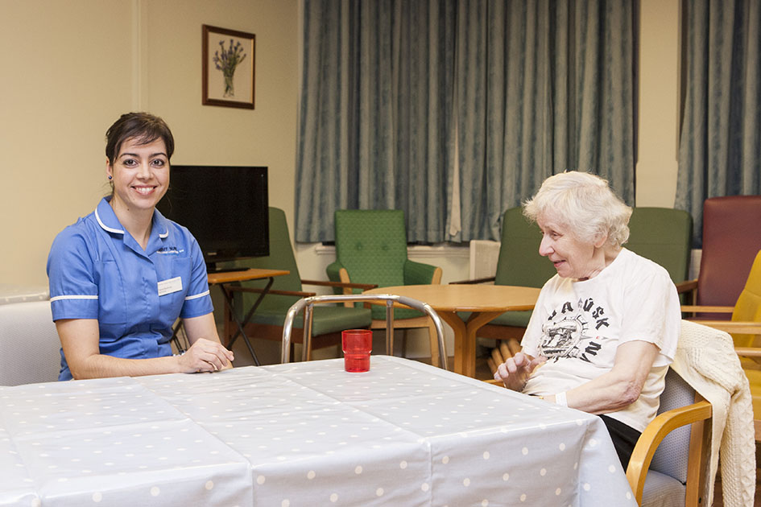
Please read out the following statement to the patient before you start asking the questions:
“This questionnaire is completely confidential. We have not entered your name, address or any other personal information. Please answer all of the questions honestly, this will ensure we gather the best possible information to help further patient experiences. There are no right or wrong answers.”

Tips
Here are some examples of how to ask the question:
“Please choose one of these words to best describe how you feel about your treatment in the hospital during your stay.”
If you are asking a patient with dementia please consider the following:
“Did you feel comfortable enough during your stay in hospital?”
...then use your interpretation to choose the best possible word.
If it’s possible for the patient to complete the questions unaided please do so.

Patient experience
Name of ward and hospital:

Date:
Your experience | Being admitted | Your first assessment | Your comfort | Communications
 |  | 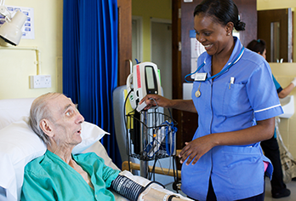 | 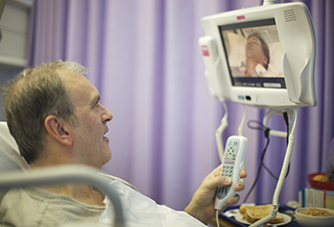
Select how
you felt
What emotion(s) best describe your experience?
(see list below)

Please add other thoughts or feedback on your experience

Emotions | happy good lonely ok confused uncomfortable  supported worried sad misunderstood unhappy frightened  safe comfortable relieved cared for annoyed other (please state)
Patient experience

Your experience | Your treatment | Hygiene | Dignity and respect | Preparing to leave hospital
 | 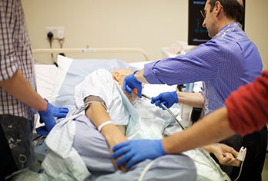 | 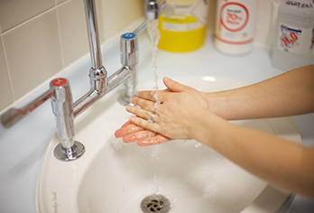 |  | 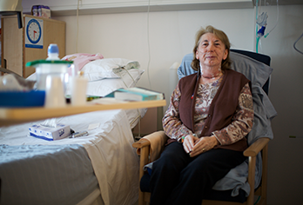
Select how
you felt
What emotion(s) best describe your experience?
(see list below)

Please add other thoughts or feedback on your experience

Emotions | happy good lonely ok confused uncomfortable  supported worried sad misunderstood unhappy frightened  safe comfortable relieved cared for annoyed other (please state)

